Nama: Jonathan Natannael Zefanya

Figma: <https://www.figma.com/design/7gUZg5iV0uwIBSOHxDOJLZ/Bank-Sampah-App?node-id=706-522&t=NzdJNQD8VAWTdIgs-1>

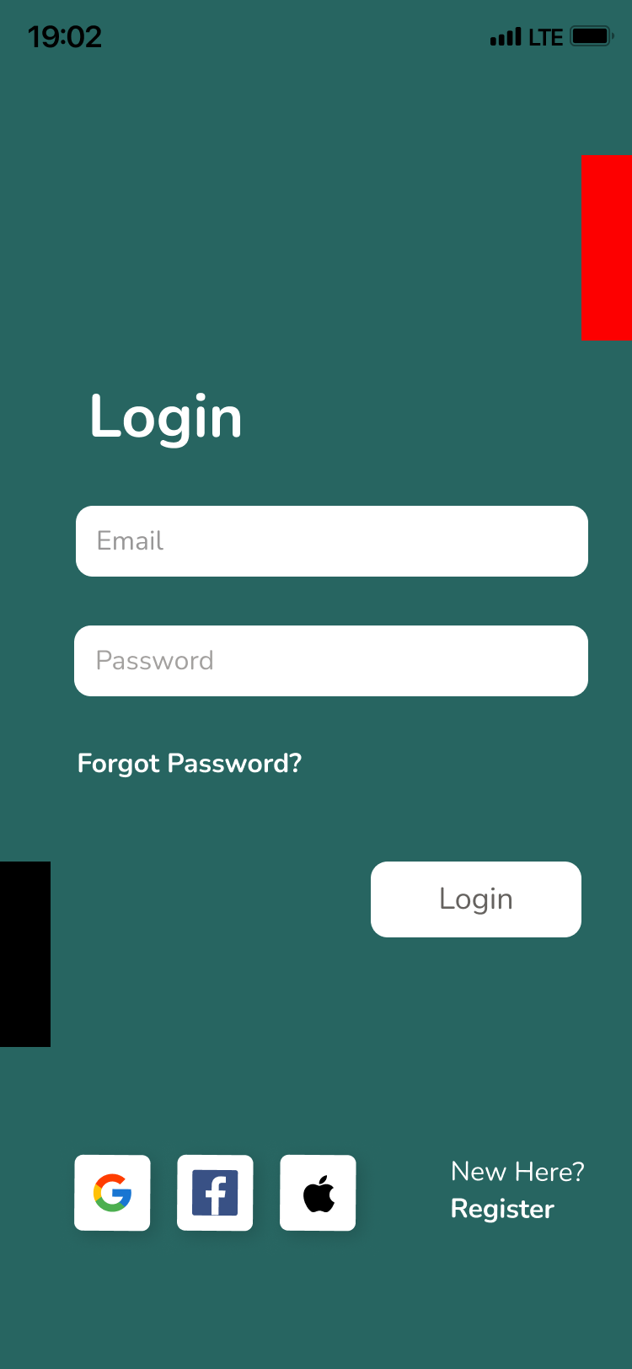

Gambar 1. Login Page

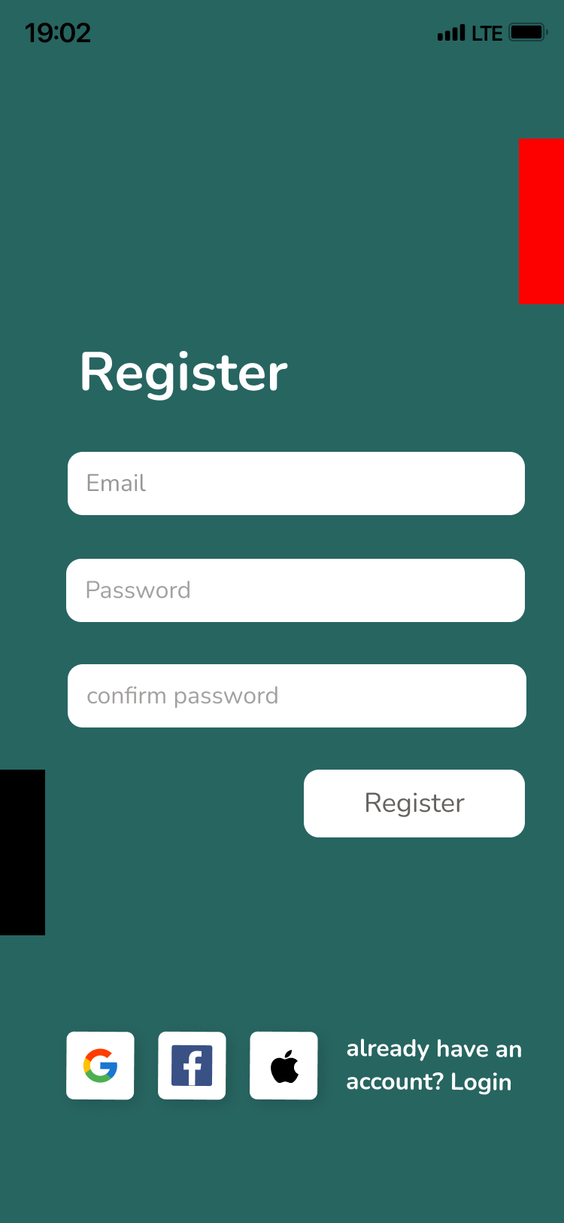

Gambar 2. Register Page

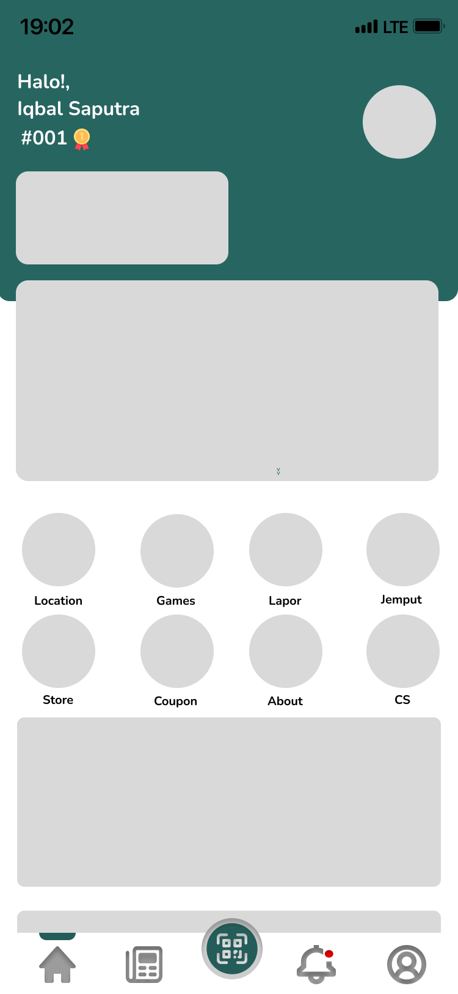

Gambar 3. Homepage

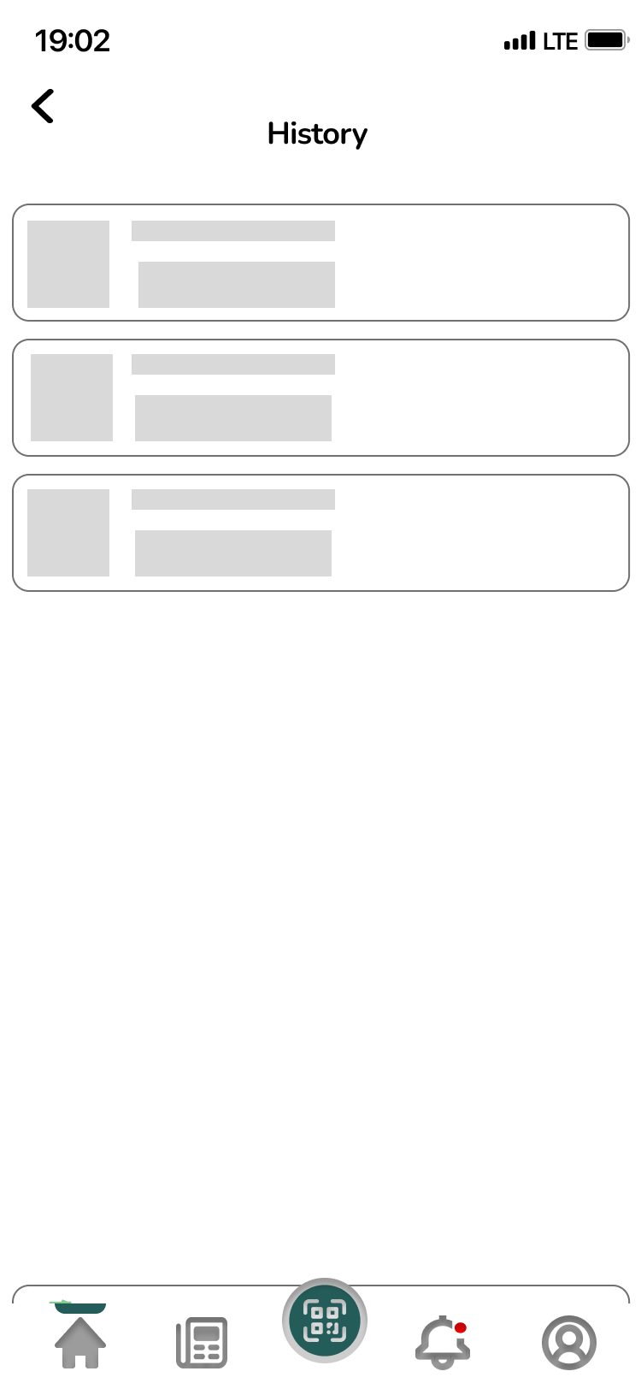

Gambar 4. History Page

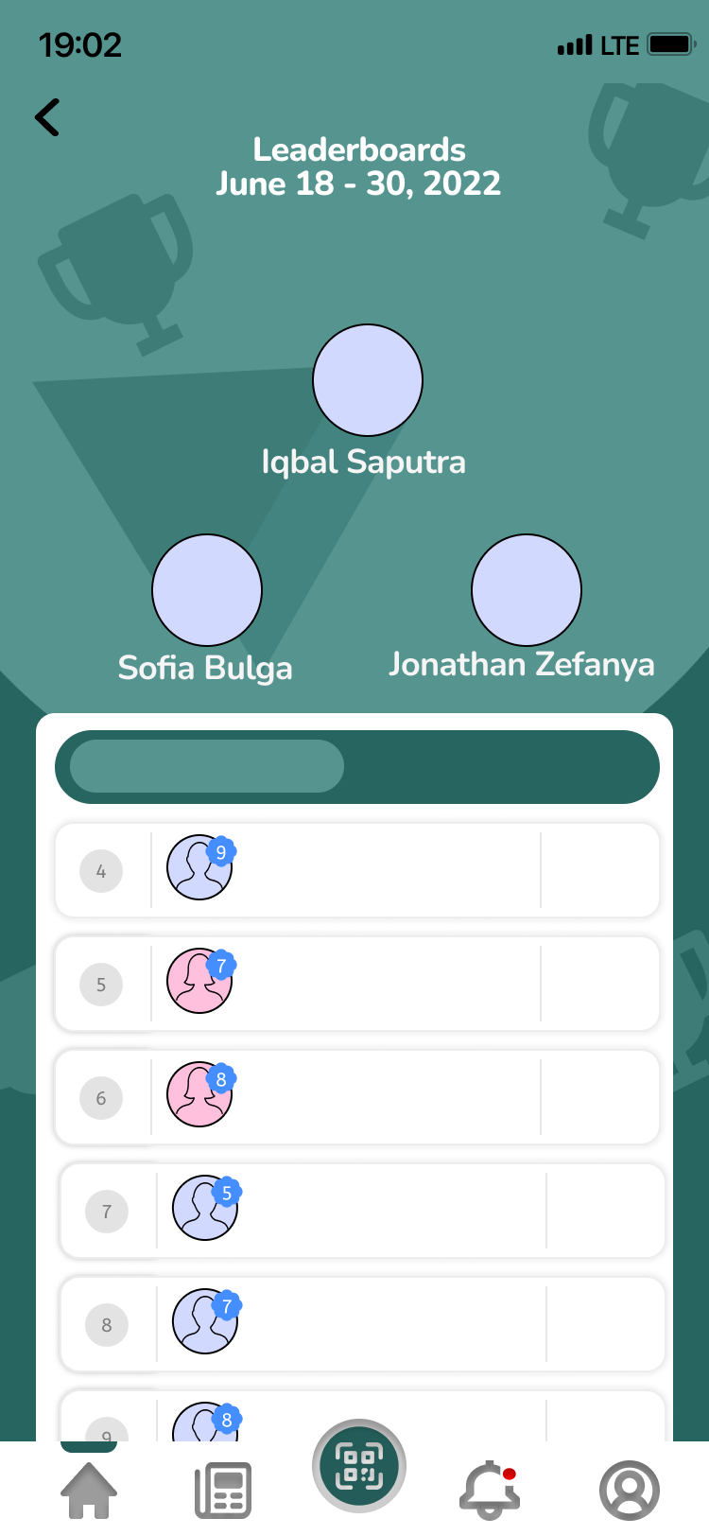

Gambar 5. Leaderboard Page